**[Type the company name]**

[Year]

**ONLINE BUS RESERVATION SYSTEM PROJECT REPORT**

**By team**

**p.v.s.vikas [17331A05C2]**

**r.v.pavankumar[17331A05E0]**

**v.tatababu[17331A05G8]**

**INTRODUCTION**:

The project titled ONLINE BUS RESERVATION SYSTEM is a software for booking online tickets . this

project is developed using php , javascript, css and html . which mainly focuses on basic operations that

user perform to book a ticket online such as **finding buses ,checking seat availability,** making **online**

**payment, registration etc** and also the operations performed by administrator such as **adding**

**buses, deleting buses , adding routes , deleting routes etc**

“online bus reservation system” is a windows application written for both 32-bit and 64-bit operating

System, designed to help users to login and book tickets ,our software is easy to use for both

beginners and advanced users.

We have used good user interface that generate interest to use our software

and we have kept good background for our html pages that attract users throughout the time period of

their usage.

There are basically three modules in this software they are

🡪admin module

🡪 user module

🡪 data base access module

**SYSTEM ANALYSIS**

**EXISTING SYSTEM:**

System analysis is a detailed study of the various operations performed by a system

and their relationships within and outside of the system . here the key question is what all problems

exist in the present system ? what must be done to solve the problem ? analysis begins when a user

or admin begins a study of the program using existing system .

there are few drawbacks in existing system such as adding or deleting roots and buses is a bit

difficult task due to availability of limited database . during peak times such as festivals and

holidays the server cannot handle all the user requests and this was the major drawback in the

existing system and user have limited scope to interact with data bases and another issue is after

adding new buses the updated details are not shown immediately which indicates data

inconsistency and basic operations such as insertion , deletion , updating data is not that much

simple.

One of the major drawback was ease of accessing data was quite slow in existing system.

Intermediate station details are hidden in the existing system.

A good analysis model should provide not only the mechanisms of problem understanding but also the

Frame work of the solution .thus it should be studied thoroughly by collecting data about the system

Then the proposed system should be analyzed thoroughly in accordance with needs.

**PROPSED SYSTEM:**

Proposed system is an automated library management system .through our software user can

Book tickets, view routes , check seat availability .

Similarly admin can update status, add buses, delete buses, add routes , and can delete routes .

Our proposed system has the following advantages .

🡪 attractive user interface

🡪 fast searching

🡪 huge data availability

🡪 quick booking

🡪 simple usage

🡪 quick access to database

🡪 security

**CASE DIAGRAM:**

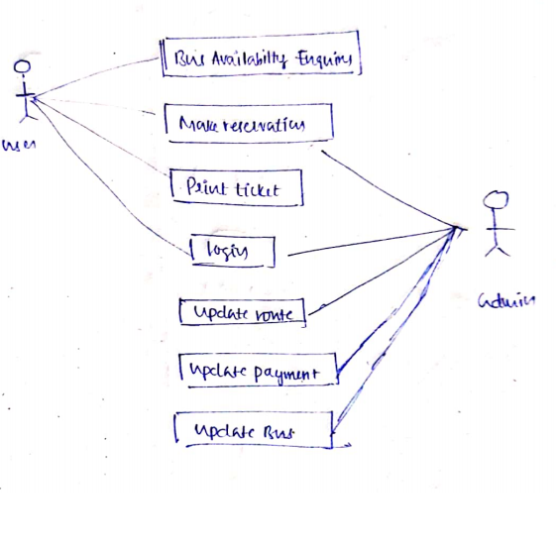

**DATA FLOW DIAGRAM:**

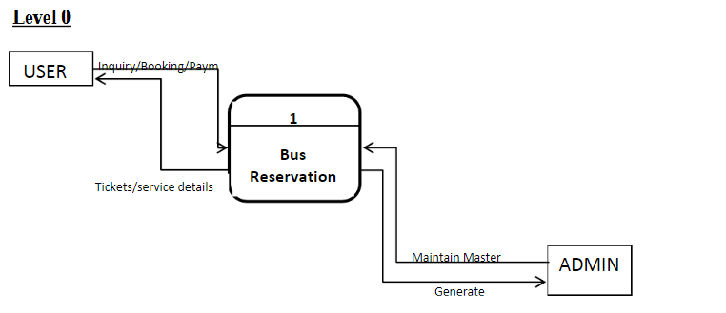

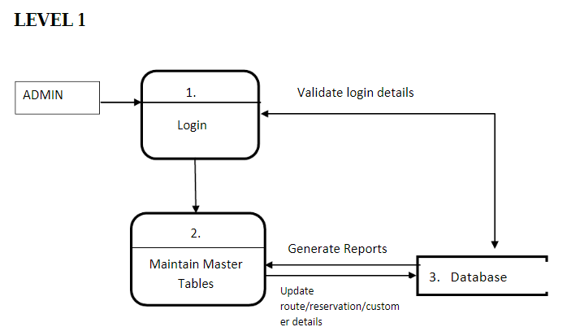

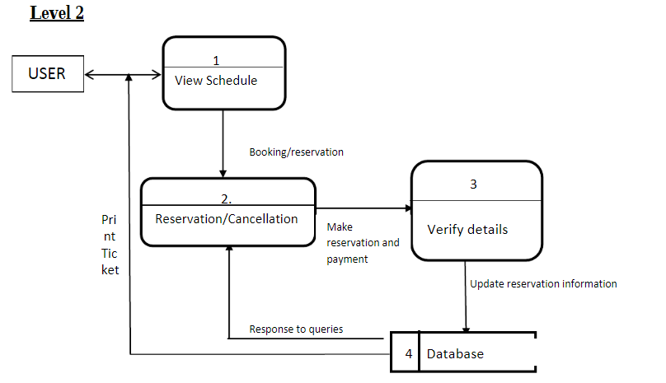

**SOFTWARE INTERFACE**:

**LOGIN PAGE:**

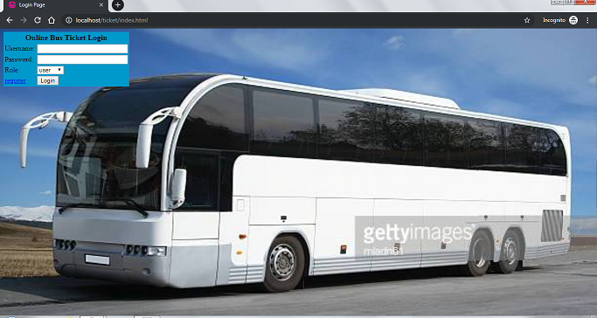

REGESTERATION PAGE:

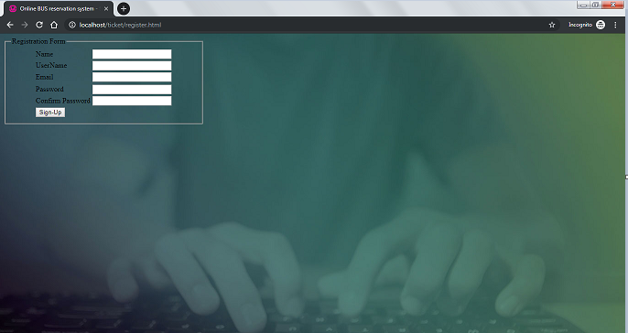

**Userlogin:**

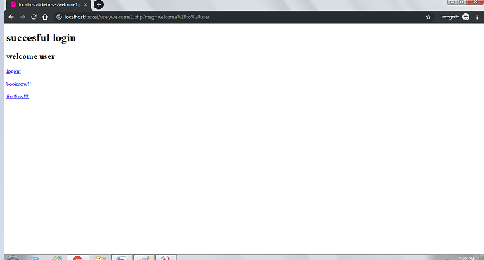

**ADMIN LOGIN:**

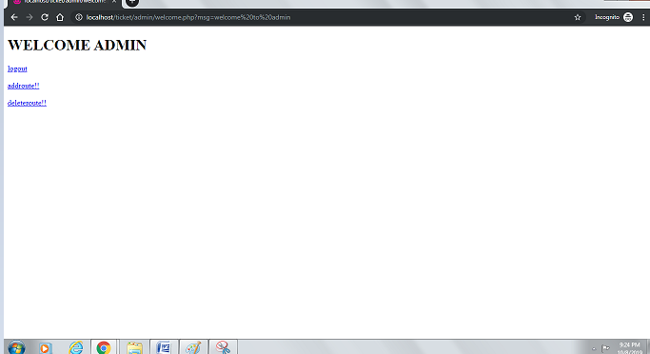

**To book seat:**

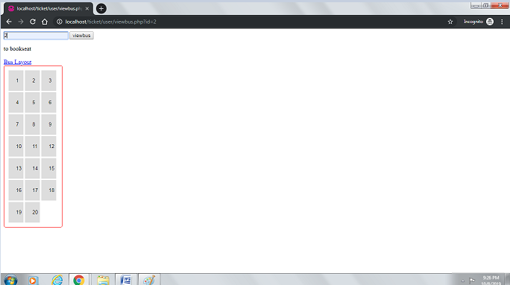

**Payment page:**

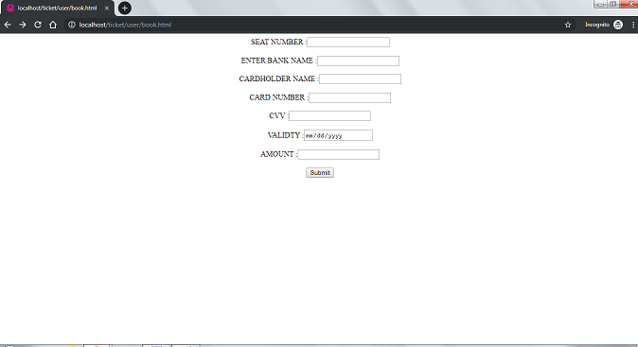

**After submitting:**

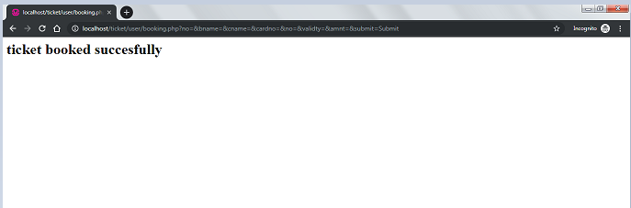

**Find bus:**

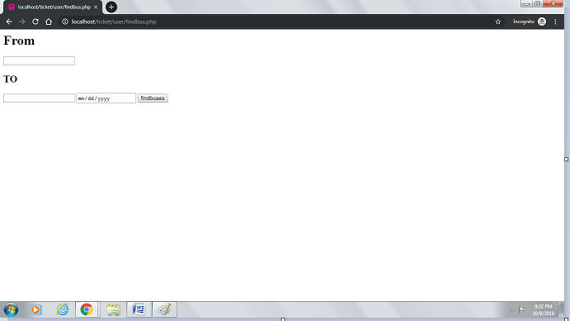

**If no buses available:**

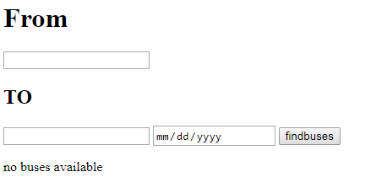

**If available:**

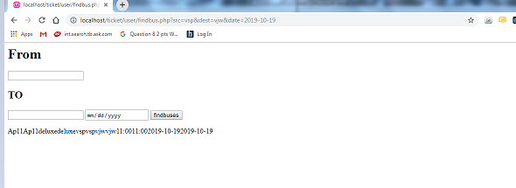

**Logout:**

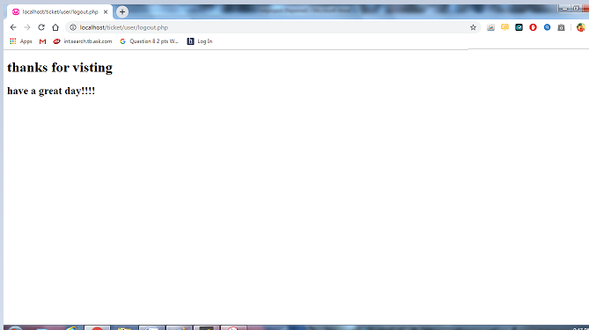

**SYSTEM DESIGN:**

**INPUT DESIGN:**

input design is the process of converting user –oriented input to a computer based format . input

design is a part of overall system design , which requires very careful attention . often the collection

of input data is the most expensive part of the system .the main objectives of the input design are

1. procedure cost effective method of input
2. achieve highest possible level of accuracy
3. ensure that the input is acceptable to and understand by the staff

input data:

The goal of designing input data is to make enter easy , logical and free from errors as possible .for

entering data user need to know the allocated space for each field, field sequence and

which must match with that in the source document , the format in which the data fields are

entered should be given in the input form , here data entry is online , it makes use of processor that

accepts commands and data from the operator through keyboard. The input required is analyized by the

processor. input stages include the following processes

such as  **data recording, data transcription, data conversion, data verification, data control, data transmission, data correction**

**OUTPUT DESIGN:**

Outputs from computer systems are required primarily to communicate the results of processing

to users .they are also to used to provide a permanent copy of these result for later consultation.

Computer output should proceed in an organized well throughout the manner.

The outputs have been defined during the logical design stage. if not ,they should defined at the

Beginning of the output designing terms of types output connect, format ,response etc.

Various outputs are

**External outputs, internal outputs ,operational outputs, interactive outputs, turn around outputs.**

**DATA BASE DESIGN:**

DATABASE DESIGN The general theme behind a database is to handle information as an integrated

whole. A database is a collection of interrelated data stored with minimum redundancy to serve many

users quickly and effectively. After designing input and output, the analyst must concentrate on

database design or how data should be organized around user requirements. The general objective is to

make information access, easy quick, 23 inexpensive and flexible for other users. During database design

the following objectives are concerned:- ¬ Controlled Redundancy ¬ Data independence ¬ Accurate

and integrating ¬ More information at low cost ¬ Recovery from failure ¬ Privacy and security ¬

Performance ¬ Ease of learning and use

**Tables used:**

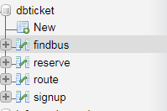

**Findbus:**

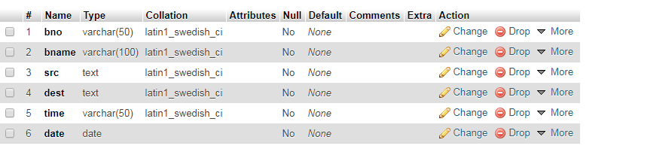

**Values inserted:**

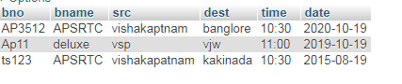

**Reserve:**

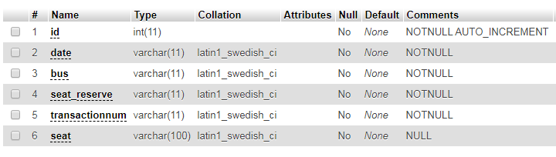

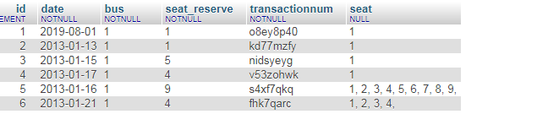

**Route:**

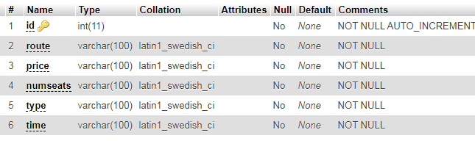

**Values inserted:**

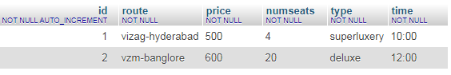

**Signup:**

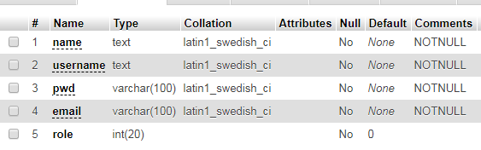

**Values inserted:**

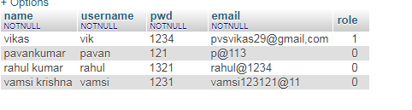

**Admin: vikas**

**Uname:vik**

**Password:1234**

SYSTEM IMPLEMENTATION

Implementation is the stage in the project where the theoretical design is turned into a working

system. The implementation phase constructs, installs and operates the new system. The most crucial

stage in achieving a new successful system is that it will work efficiently and effectively. There are

several activities involved while implementing a new project they

• End user training 26

Education

• Training on the application software

• System Design

• Parallel Run And To New

System

Post implementation Review End user Training: The successful implementation of the new system will

purely upon the involvement of the officers working in that department. The officers will be imparted

the necessary training on the new technology. End User Education: The education of the end user start

after the implementation and testing is over. When the system is found to be more difficult to under

stand and complex, more effort is put to educate the end used to make them aware of the system,

giving them lectures about the new system and providing them necessary documents and materials

about how the system can do this.

Training of application software: After providing the necessary basic training on the computer

awareness, the users will have to be trained upon the new system such as the screen flows and

screen .

design type of help on the screen , type of errors while entering the data , the corresponding validation

check at each entry and the way to correct the data entered. It should then cover information

needed

by the specific user or group to use the system. 27 Post Implementation View: The department is

planning a method to know the states of t he past implementation process. For that regular meeting

be arranged by the concerned officers about the implementation problem and success.

**SOFTWARE TESTING**

Is the menu bar displayed in the appropriate contested some system related features included either in

menus or tools? Do pull –Down menu operation and Tool-bars work properly? Are all menu function and

pull down sub function properly listed ?; Is it possible to 28 invoke each menu function using a logical

assumptions that if all parts of the system are correct, the goal will be successfully achieved .? In

adequate testing or non-testing will leads to errors that may appear few months later. This create two

problem 1. Time delay between the cause and appearance of the problem. 2. The effect of the system

errors on files and records within the system The purpose of the system testing is to consider all the

likely variations to which it will be suggested and push the systems to limits. The testing process focuses

on the logical intervals of the software ensuring that all statements have been tested and on functional

interval is conducting tests to uncover errors and ensure that defined input will produce actual results

that agree with the required results. Program level testing, modules level testing integrated and carried

out. There are two major type of testing they are

1) White Box Testing.

2) Black Box Testing. White Box

Testing White box some times called “Glass box testing” is a test case design uses the control structure

of the procedural design to drive test case. Using white box testing methods, the following tests where

made on the system 29 A) All independent paths within a module have been exercised once. In our

system, ensuring that case was selected and executed checked all case structures. The bugs that were

prevailing in some part of the code where fixed

b) All logical decisions were checked for the truth and

falsity of the values. Black box Testing Black box testing focuses on the functional requirements of the

software. This is black box testing enables the software engineering to derive a set of input conditions

that will fully exercise all functional requirements for a program. Black box testing is not an alternative

to white box testing rather it is complementary approach that is likely to uncover a different class of

errors that white box methods like..

1) Interface errors 2) Performance in data structure 3) Performance errors 4) Initializing and

termination errors.

**CONCLUSION :**

Our project is only a humble venture to satisfy users in booking online tickets

. Several user friendly coding have also adopted. This package shall prove to be a powerful package in

satisfying all the requirements of the organization.